Supplementary Materials

Patients admitted to the ward
Hemodynamically stable
Contraindication for EN
Resuscitation
Consider PN on
day 5-7
NG tube
Start EN 10-20 mL/h
Assess GRV q 4 h
GRV>250 mL
Metoclopramide iv
Decreased EN rate
Increased EN rate until caloric goal
Supplementary Fig. 1. Songklanagarind Hospital feeding protocol. EN: enteral nutrition; GRV: gastric residual volume; NG: nasogastric; PN: parenteral nutrition.

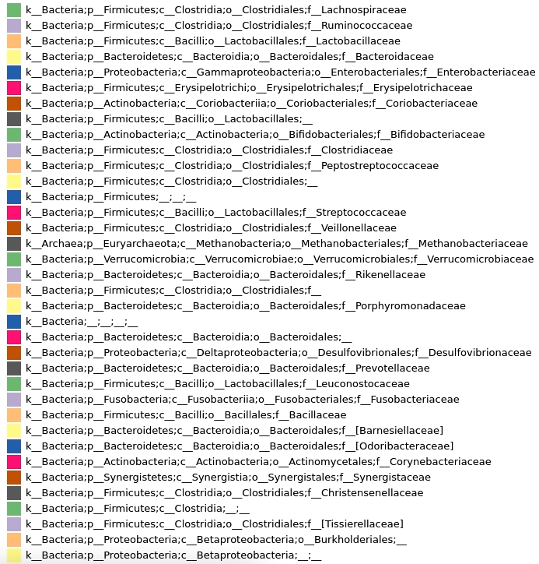
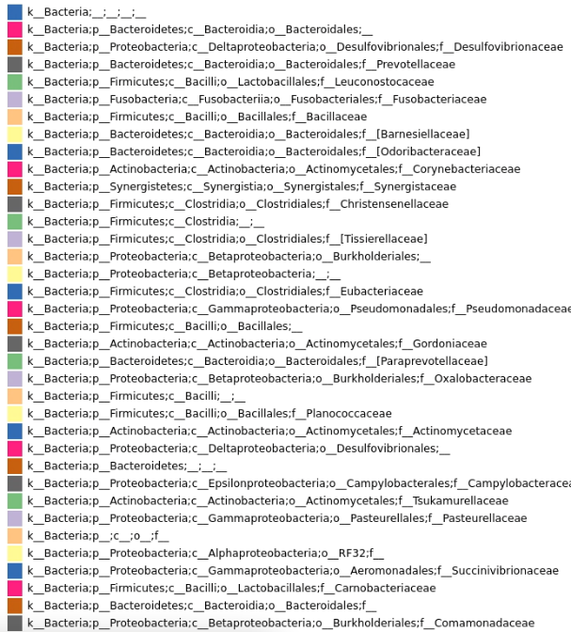

Supplementary Fig. 2. Taxonomic plot genus composition.

Supplementary Table 1. Comparison of the rectal enema between the synbiotics and non-synbiotics groups.
Variables | Total (n = 24) | Synbiotics (n = 12) | Non-synbiotics (n = 12) | p-value
Rectal enema for the first collected sample | 7 (29.2) | 3 (25) | 4 (33.3) | 0.653
Rectal enema for the second collected sample | 8 (33.3) | 4 (33.3) | 4 (33.3) | 1.000
Data are presented as n (%).

